**Lab assignment 4.**

q- 1) Find out the names of clients who stays in a city whose second letter is ‘a’.

q-2) Print the list of clients whose bal_due is greater than value 10000.

q-3) Print the information from sales_order table for orders placed in the month of January.

q-4) Display the order information for client_no ‘C00001’ and ‘C00002’.

**Output:**

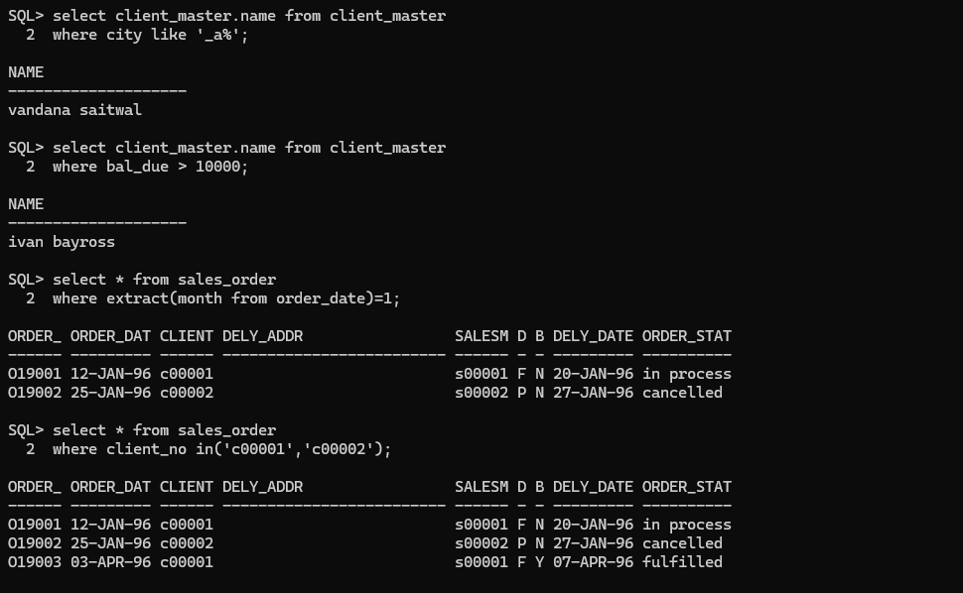

q-5) Find products whose selling price is greater than 2000 and less than or eqal to 5000.

q-6) Find products whose selling price is more than 1500. Calculate a new selling price as,

Original selling price *.15. Rename the new column in the above query as

new_price.

q-7) List the names, city and state of clients who are not in the state of

‘Maharashtra’.

q-8) Count the total number of orders.

**Output:**

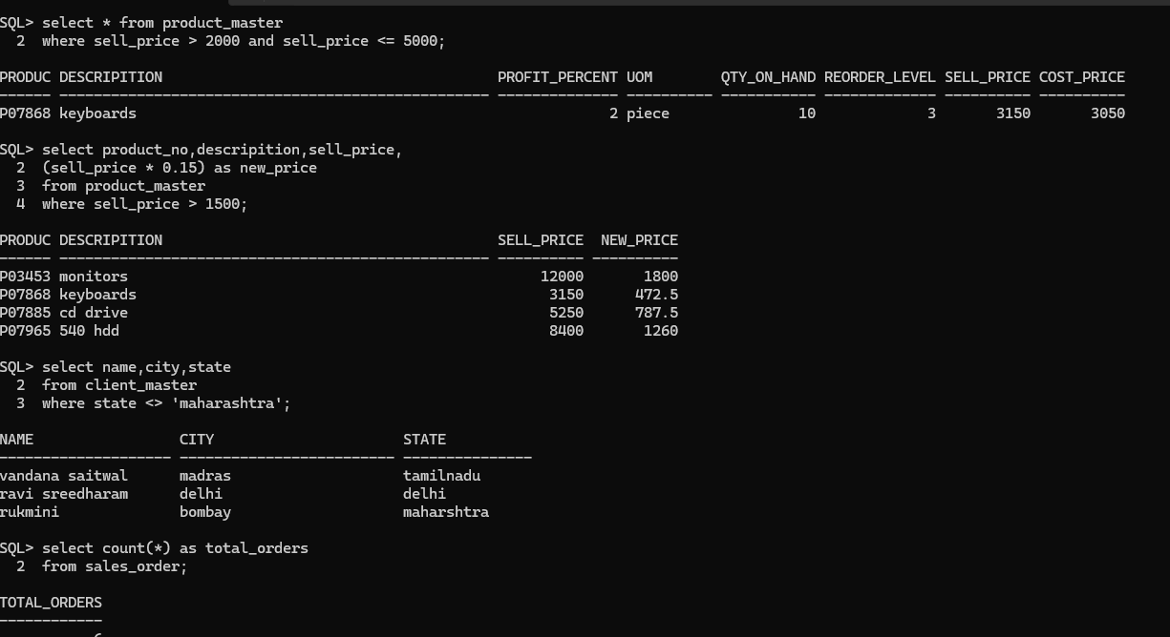

q-9) Calculate the average price of all the products.

q-10) Determine the maximum and minimum product prices. Rename the

output as max_price and min_price respectively.

q-11) Count the number of products having price greater than or eqal to 1500.

**Output:**

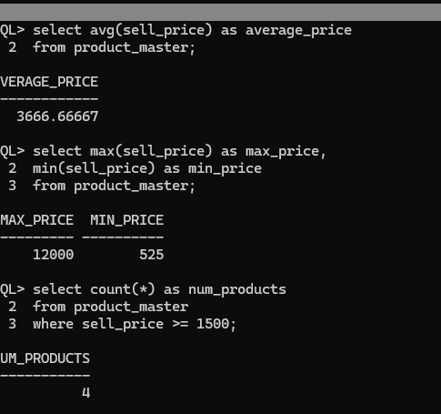

q-12) Find all the products whose qty_on_hand is less than reorder level.

q-13) Display the order number and day on which clients placed their order.

q-14) Display the month(in alphbets) and date when the order must be delivered.

**Output:**

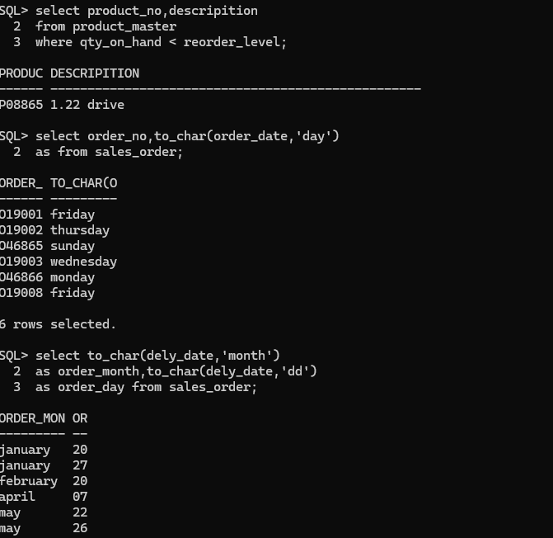

q-15) Display the order_date in the formate ‘DD- Month – YY’.

q-16) Find the date, 15 days after today’s date.

q-17) Find the number of days elapsed between today’s date and the delivery date of the orders placed by the clients.

**Output:**

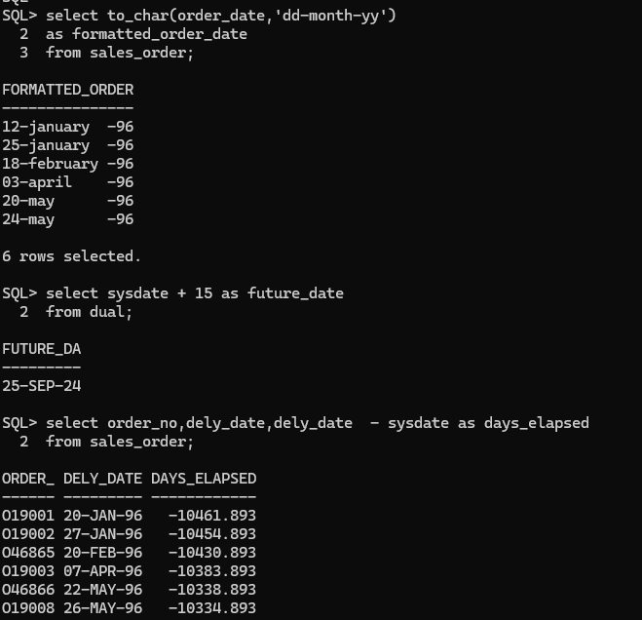

q-18) Print the description and total qty sold for each product.

**Output:**

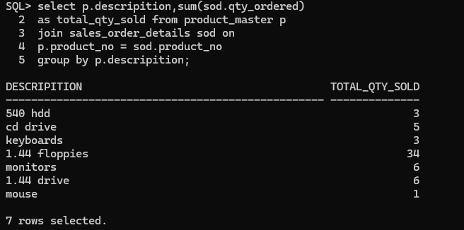

q-19) Find the value of each product sold.

**output:**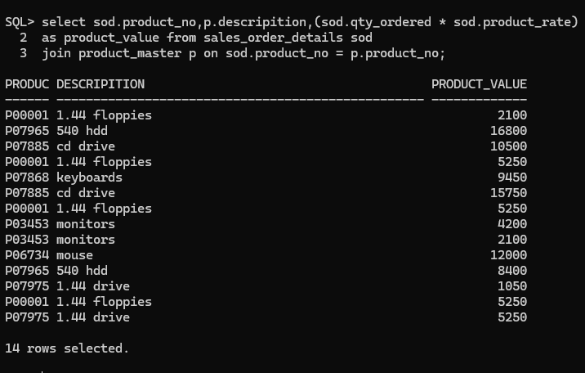

q-20) Calculate the average qty sold for each client that has a maximum order value of15000.

**Output:**

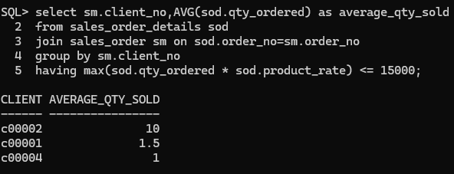

q-21) Find out the sum total of all billed orders for the month of January.

q-22) Find out the products, which have been sold to ‘Ivan Bayross’.

**Output:**

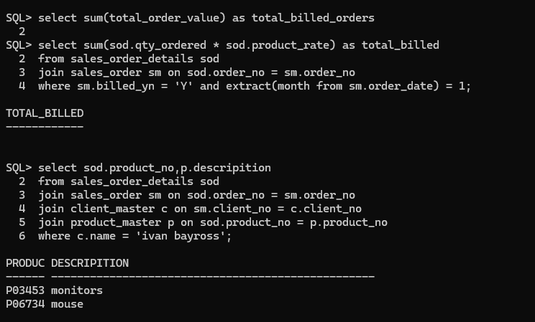

q-23) Find out the products and their quantities that will have to be delivered in the current month.

q-24) Find the product_no and description of constantly sold i.e. rapidly moving products.

**Output:**

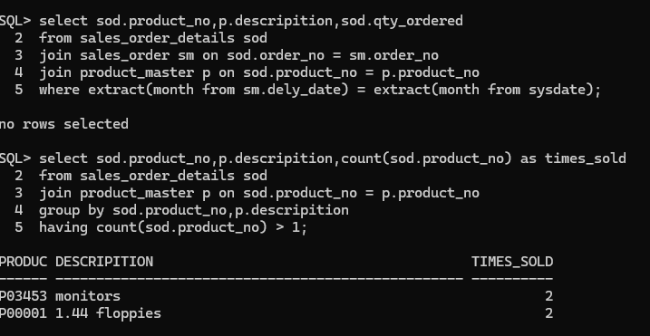

q-25) Find the names of clients who have purchased ‘CD Drive’.

q-26) Find the products and their quantities for the orders placed by ‘Ivan Bayross’ and ‘Vandana Saitwal’.

q-27) Find the products and their quantities for the orders placed by client_no ‘C00001’ and ‘C00002’.

**Output:**

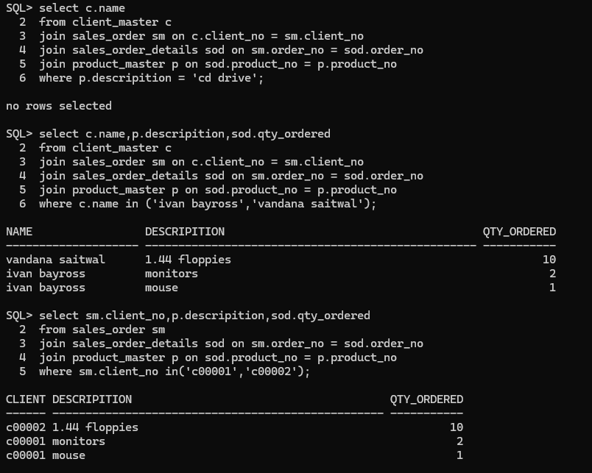

q-28) Find the product_no and description of non moving products i.e. products not being

sold.

q-29) Find the client names who have placed order before the month of May ’96.

**Output:**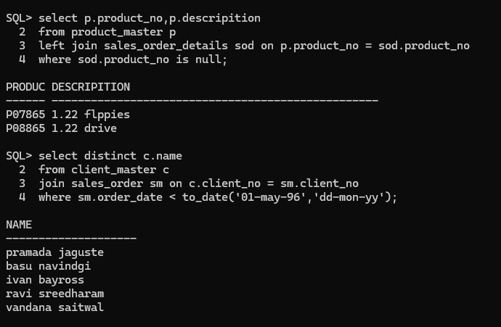

q-30) Find the names of clients who have palced orders worth Rs. 10000 or more.

**Output:**

